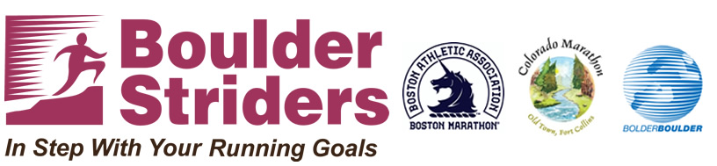
Boston or Colorado Marathon plus Bolder Boulder Training
Training Details
- 14 Week Training Program, training ends May 25th.
- Training begins the week of Feb 16th (FIRST MEETING – Wed Feb 18th)
- Base Meeting Times: Wednesday’s @ 6:30 am OR 5:30 pm and Saturday’s @ 7:30 am
- There will be 2 TRAINING GROUPS: A & M with all abilities welcome
  - "A" meeting Wed @ 5:30 pm and Sat @ 7:30 am
  - "M" meeting Wed @ 6:30 am and Sat @ 7:30 am
- ALL participants receive a Boulder Striders Tech Shirt
- Bring a NEW MEMBER to training ($25 discount for you / $15 discount for new member)
Boulder Striders’ Program Rates
$225 | 14 week program | includes 14 weeks of twice a week training
MAKE CHECKS PAYABLE TO: BOULDER STRIDERS
OR CREDIT CARD...ADD $8 TO THE PROGRAM RATE
Please Print & Mail Registration to:
Boulder Striders, 4162 Saint Croix St, Boulder, CO 80301 OR Bring to First Meeting
2015 Spring Training Form
Last Name |  |  | First Name
Address
City |  |  | State |  |  | Zip
DOB |  | Email
Day Phone |  |  | Evening Phone

 |  | Group A: Wed/Sat (5:30 pm /7:30 am ) |  |  |  |  |  |  |  |  | Group M: Wed/Sat (6:30 am / 7:30 am )
Tech Shirt Size |  |  | Women’s |  | S |  | M |  | L | Men’s |  |  | S |  | M |  | L |  | XL

Signature: __________________________________________
By signing this Registration Form, I do not hold Colleen De Reuck, Boulder Striders or any of the Coaches liable for injury to myself during the 14 week training. One form per participant. Photocopies are okay.

